Welcome back and in this lesson I want to talk about three different products which make it easy to migrate huge quantities of data in and out of AWS. Now, those products are **Snowball, Snowball Edge, and Snowmobile** and I want to talk about each of them in turn because each of them has their ideal use cases and some really interesting feature.

Before I do want to talk in general and the **Snowball set of products are going to be used when you have a huge amount of data to actually send into AWS or pull out of AWS. All of the Snowball devices are essentially big, portable, hard drives.** Now, you'll see when I talk about the Snowmobile, that definition is stretched it a little bit but at least for the Snowball and Snowball Edge, it's a suitcase sized data storage device. Now, the way that this works is you essentially via the AWS console book a Snowball job and that job can either be to take data out of S3 or add data into a S3. **You can create either incoming or outgoing jobs,** and in either case, AWS will ship you one or more Snowball or Snowball Edge devices and I'll be talking about how Snowmobile is different later in this lesson but for both Snowball and Snowball Edge the process is much the same. Now you'd **use the Snowball devices when you've got a large amount of data, you've got limited internet bandwidth, and it just wouldn't be economical to transfer all that data over the wire into S3. So this is the type of use case when you've got limitations on how much date you can transfer or you've got time requirements that mean that transferring this huge quantity of data over an internet connection would just be prohibitive, either from a time perspective or a cost perspective, if you do have to pay for data transfer.** So think of it conceptually as a large network connectable hard drive, suitcase sized, you book a job, they arrive on premise, you either put data onto them, take data off of them, and then they get shipped back to AWS and that at high level is exactly what Snowball is.

Now a Snowball was the first **type of device that AWS offered for this function it's the most basic in terms of its functionality. It comes in two different sizes. You've got 50 TB raw capacity with 42 TB of usable capacity, and that's only available in the U.S. regions.** In the rest of the world, the Snowball comes with an 80 TB raw capacity and 72 TB of usable storage. So you log a job, you get the Snowball, it arrives on your business premise, and then you can connect it to your network, either using a 1 gig connection. So that's an RJ45 connection uses 1Gbase-TX based TX, or you got the option of a 10 gig connection on that uses five and that's LR/SR fiber, and that obviously uses an SPF type connection. Now any data that you transferred to or from the device it is encrypted, so it is entirely safe to store even sensitive data on these Snowball devices. If you've got any jobs that a bigger than a single device, then you can use multiple Snowball devices to transfer sections of that data and, of course, you've got the option if you do have multiple business premises, each with their own individual data storage you can obviously ship multiple Snowballs out and have each of those arriving on your individual premises. Do the data transfer in or out, and then ship the device is back and the end to end process time for using the Snowball is fairly low. A full turnaround—so that's logging the request. getting the Snowball delivered, transferring the data, sending it back, and having that data appear inside AWS or vice versa—can generally be conducted in weeks. It's not a process that takes months to organize. Now generally, you'd use a Snowball device when you've got data to migrate, that's in the range of 10 TB to 10 PB. So anything that's inside that range tends to be the sweet spot. The ideal use case for using the Snowball. For anything that's less, you should investigate using one of the other migration technologies, either transferring it direct to S3 or using something like a Storage Gateway that I'll be talking about in the next topic of the course. So the **sweet spot for a Snowball is anywhere in the 10 TB to 10 PB range**. So that's the Snowball, and that was the first device available from AWS for this function. So once the device arrives on site, you've got two different options that you could use to transfer data to or from that. You can use a Snowball client that gets installed on a local compute device and that allows you to transfer data in or out. You've also got the Amazon S3 adapter. So that's something that you install on the Snowball and once you've done that, then you can configure things like your AWS command line tools to use the Snowball as an S3 endpoint and transfer data directly.

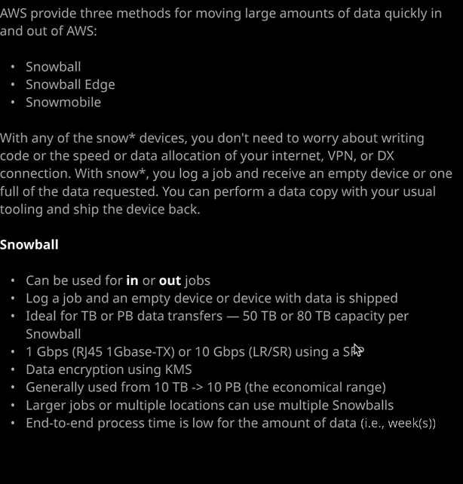

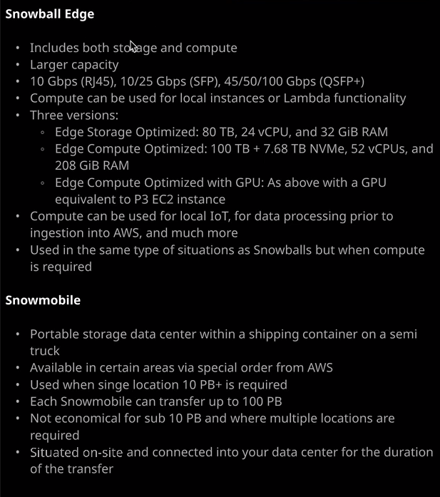

Now the Snowball Edge in addition to having the same sort of storage architecture that you get with a Snowball, this includes additionally local compute capability. Now, the standard storage that you get with a Snowball Edge is more than a standard Snowball. So **by default you get 100 TB of raw storage per Snowball Edge with 83 TB of usable capacity but because Snowball Edge comes with local compute capability there are some other differences as well**. So we start with the fact that the networking connection for a Snowball Edge is different. **The networking options you've got is 10 GBPS so a 10 gig connection over RJ45 copper, 10 or 25 gb over fiber, and then 45 50 or 100 gb over fiber as well**. So you got three different options. Copper, standard fiber, and then fast fiber. So the fast fiber is available at 45, 50, and 100 GBPS and that uses the QSFP plus standard. So keep that in mind if you do want to take advantage of those faster speeds, you need to have the hardware on site to take advantage of it. Now the unique feature about a **Snowball Edge is that it can perform local compute. You've got the ability to run local instances or execute Lambda functions locally, so this is the type of functionality that you might use if you got any local IOT requirements or if you need to process data prior for ingesting that data into AWS. So maybe as data gets loaded up onto a Snowball Edge, you want to run a Lambda function and have it perform some kind of analysis for modification of that** data but essentially, when it comes to exam questions, a **Snowball Edge adds that additional compute capability and this Snowball Edge comes in three different variants. We've got this Snowball Edge storage optimized version, which includes 80 TB of storage, 24 Virtual CPUs, and then 32 gb of RAM. We've got Snowball Edge, which is compute optimized, which includes 100 TB as well as 7.6 TB of super fast SSD directly connected storage.** So this is storage that is directly connected to the PCI express bus and so it's super fast, so you don't get as much of it but it is available for any really demanding computing tasks. It includes 52 virtual CPUs and 208 gb of RAM and then, lastly, **we've got the Snowball Edge compute optimized with GPU, and that's basically the same as the compute optimized one but it includes a GPU that's equivalent to a P3 EC2 instance. So again, the Snowball Edge is something that you would utilize for similar situations as the Snowball so the same sweet spot of data so between 10 TB and 10 PB but you would use a Snowball Edge if you had that local compute requirement**. So that's important to remember for the exam. Now a Snowball Edge could be accessed in much the same way as a Snowball. So you've got a Snowball client that can be installed on a local machine. You've got the Amazon S3 adapter, which allows you to use those native S3 command line tools to interact with storage but you've also got the file interface and **that allows you to essentially present storage through NFS, which is a network file system, so you can mount those NFS mount points on servers which support that and then transfer data into that directly.** So that's another advantage of the Snowball Edge and then, lastly, I want to talk about the Snowmobile.

Now the Snowmobile is actually a truck with a data center on the back, and I'm not exaggerating. So the Snowmobile was the most recent addition to the Snow suite of data transfer products. It's essentially a **portable storage data center inside a shipping container on a semitruck**. That is pretty much what it is. You order it, and obviously you have to order it using a special process. It's available in certain areas. It is currently special order, but when you order it essentially, a truck drives up to your business premises. It's connected directly into your data center with high speed networking and power and air conditioning. It runs while you transfer that data and then it drives off, goes back to the local AWS location, and that data is ingested into AWS. So it's essentially a super large Snowball or Snowball Edge. So it does come with some important considerations. **First is that it is not economical to use this to transfer any less than 10 PB.** If you transfer in less then you would be better using multiple Snowballs or Snowball Edges and that's especially true when multiple locations are required. So if you need to use multiple locations if your data's spread geographically, Snowmobile is not the option. Now **each Snowmobile can transfer upto 100 petabytes of data, but do keep in mind it is simply not economical for anything less than 10 or where multiple locations are required. This is a physical truck it drives to a physical location. It needs to be a data center location because it does have more extensive requirements. It does need power. It does need data. It does need to keep itself cool. It is self contained but it is not something that you can get to drive up to a standard business premise, park in the parking lot, and just connect it using normal power connectors, for example, it needs to be a data center.** So for the exam, I don't expect the Snowmobile to feature but if there are any questions that do need huge amounts of data than it should be, the first thing that you think of. It's still a fairly niche product, though, so I probably won't expect to see it in many exam questions if it all. But you are likely to face questions on Snowball Snowball Edge. I just wanted to introduce the full suite of products, so that you've got a little bit more confidence when you're choosing between them. Now that being said, that is everything that I wanted to cover in this lesson and this topic, it's only been a single lesson topic. Now, in the next topic, we're going to talk about two additional data transfer and database migration products. So we've got the Storage Gateway, which is an AWS hybrid storage product and we've got the Database Migration Service. So they're two really important things for the exam. So go ahead, mark this lesson as complete and when you ready, join me in the next topic.